**Neenah Public Library Board of Trustee Meeting Minutes – November 20, 2024**

The meeting of the Neenah Public Library Board of Trustees held on November 20, 2024, in the Shattuck Community Room, was called to order by McMahon at 4:01 p.m.

Members present: Carol Codner, Tami Erickson (Aldermanic representative), Randy Fieldhack, Lisa Hemes, Elizabeth Irish, Joshua Kutney, Jenn McMahon (Vice President, Neenah Joint School District representative), Pat Rickman, George Scherck (Winnebago County representative), Harrison Flint (teen representative), and Alivia Haller (teen representative).

Members excused: Michael Koller (president).

Also present, Nicole Hardina-Wilhelm, director, Nancy Baird, circulation services manager, Mehta Hess, adult services manager, Katrina Wulff, youth services manager, and Flo Bruno.

**Minutes**

On motion of Erickson, seconded by Fieldhack, the Board approved the Library Board meeting minutes of October 16, 2024. Scherck abstained.

**Director’s and Technical Services Report**

Director Hardina-Wilhelm spoke about the library’s Speed Puzzling Tournament.

**Department reports**

Adult Services Department   
Hess talked about the success of the True Crime Series, Edgar Allen Poe program, and Repair Café. She also noted a library story about a gentleman unconnected with the Repair Café ended up staying to help with a wide variety of projects.

Circulation Services Department   
Baird gave a report on the food drive—up from the last two drives—and new library accounts created based on residents’ county. Baird shared a library story from a patron complimenting the library on our “Coffee at the Library” and turning the library into a destination instead of just a book depository.

Youth Services Department   
Wulff was on Local 5 Live, she talked about the 881 people that came to the Bluey Bonanza and that we received many compliments about how well it was run. She shared a library story submitted by a family who has been enjoying the library for over 70 years. How it has always been a wonderful, magical, safe, and happy place.

**Bills for consideration**

On the motion of Fieldhack, seconded by Rickman, the Board unanimously approved payment of the November bills.

**Patron Ban**

On the motion of Irish, seconded by Hemes, the Board approved the motion to ban a patron from the Library for one year.

**Community Survey**Director Hardina-Wilhelm discussed the meetings with Blue Door and the timeline for the community survey and branding project.

**Hoopla Update**

On the motion of Fieldhack, seconded by Scherck, the Board approved the use of $4,350 from the Trust Fund to supplement Hoopla.

**Library Closure Dates**

On the motion of Fieldhack, seconded by Hemes, the Board approved the additional closed dates of July 5 and July 6, 2025.

**Next regularly scheduled meeting**

Wednesday, December 18, 2024, at 4:00 p.m. in the Shattuck Community Room.

**Adjournment**

On motion of Hemes, seconded by Erickson, the Library Board adjourned at 5:09 p.m.

Respectfully submitted,

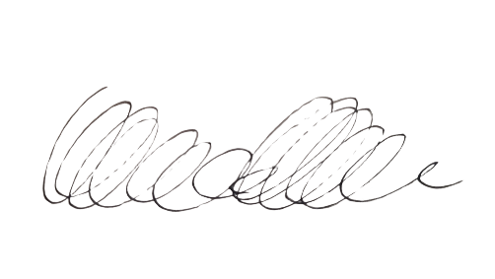

Katrina Wulff